**APPENDIX D**

**FPGA Configuration Mode (Taken from SoCKit User Manual)**

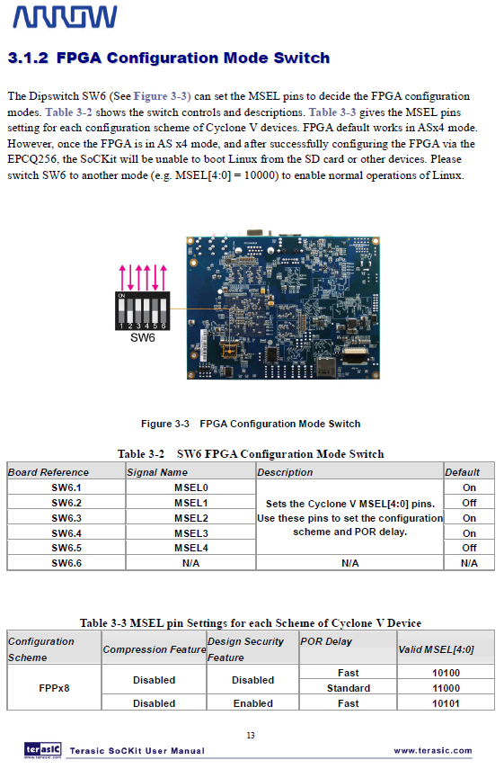

**APPENDIX D (CONTINUED)**

**FPGA Configuration Mode (Taken from SoCKit User Manual)**

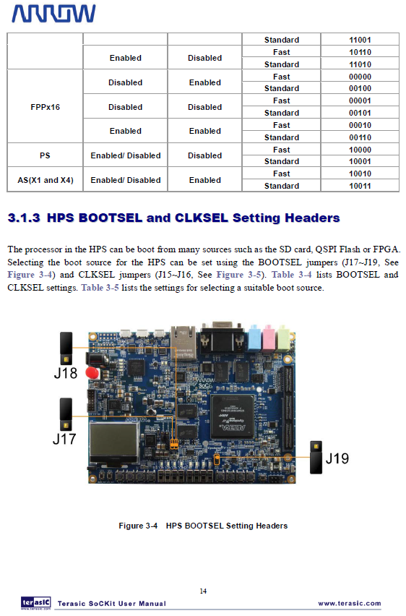

**APPENDIX D (CONTINUED)**

**FPGA Configuration Mode (Taken from SoCKit User Manual)**

